温州大学数理与电子信息工程学院
路由与交换 实验报告
备注：实验包括基本技能、进阶技能和创新技能，如果没有创新技能方案则最高分为90分，
实验名称： | 实验七 BGP的配置与管理
班 级： |  | 姓 名： | 刘军 | 学 号：
实验地点： |  | 日 期：

一、实验目的：
- 了解BGP协议的工作原理，理解BGP对等体的概念与类型
- 理解BGP的路径选择过程，掌握应用路由映射实现策略路由的方法
- 掌握BGP协议的规划、配置、测试与故障排除

二、基本技能实验内容、要求和环境：
如图所示的网络拓扑，要求采用BGP与RIP协议的组合使得该网络中的所有网段之间能够相互通信。
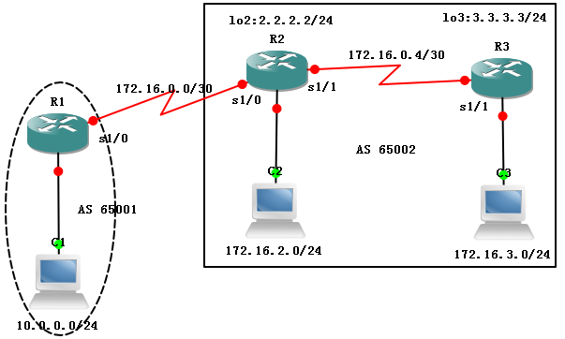
表1 “BGP的配置与管理”之相关规划
规划内容 | 规划要点 | 参考建议
网络环境的搭建 | 线缆的选择、网络设备型号、网络设备数以及网络设备之间的物理连接 | 略
路由器的基本配置 | 路由器主机名，特权密码、Telnet，路由器接口的IP地址 | 略
IP地址的分配 | 每个网段的IP网络号，PC的IP地址、子网掩码、默认网关 | 见图6.9.1
RIP的配置 | 参与RIP更新的路由器与接口 | 规划提示：仅自治系统65002中的路由器R2与R3启动RIP路由进程  路由器R2参与更新的网络有172.16.0.4/30、172.16.2.0/24与2.2.2.0/24  路由器R3参与更新的网络有172.16.0.4/30、172.16.3.0/24与3.3.3.0/24
BGP的配置 | 自治系统划分、启动BGP的路由器、邻居与需要宣告的网络 | 规划提示：所有路由器启动BGP路由进程，其中R1属于自治系统65001，R2与R3属于自治系统65002  路由器R1上被宣告的直连路由有：10.0.0.0/24  路由器R2上被宣告的直连路由有：172.16.2.0/24  路由器R2上被宣告的直连路由有：172.16.3.0/24
路由的测试 | 通过主机测试  通过路由器测试 | ping、tracert  ping、扩展ping、traceroute  show ip bgp summary、show ip bgp neighbors

三、基本技能实验结果与分析：
1. 配置路由器名称与接口IP地址：
R1#show ip interface brief
Interface IP-Address OK? Method Status Protocol
FastEthernet0/0 10.0.0.1 YES manual up up
FastEthernet0/1 unassigned YES unset administratively down down
Serial1/0 172.16.0.1 YES manual up up
Serial1/1 unassigned YES unset administratively down down
Serial1/2 unassigned YES unset administratively down down
Serial1/3 unassigned YES unset administratively down down

R2#show ip interface brief
Interface IP-Address OK? Method Status Protocol
FastEthernet0/0 172.16.2.1 YES manual up up
FastEthernet0/1 unassigned YES unset administratively down down
Serial1/0 172.16.0.2 YES manual up up
Serial1/1 172.16.0.5 YES manual up up
Serial1/2 unassigned YES unset administratively down down
Serial1/3 unassigned YES unset administratively down down
Loopback2 2.2.2.2 YES manual up up

R3#show ip interface brief
Interface IP-Address OK? Method Status Protocol
FastEthernet0/0 172.16.3.1 YES manual up up
FastEthernet0/1 unassigned YES unset administratively down down
Serial1/0 unassigned YES unset administratively down down
Serial1/1 172.16.0.6 YES manual up up
Serial1/2 unassigned YES unset administratively down down
Serial1/3 unassigned YES unset administratively down down
Loopback3 3.3.3.3 YES manual up up

2. 配置主机IP地址、掩码与网关
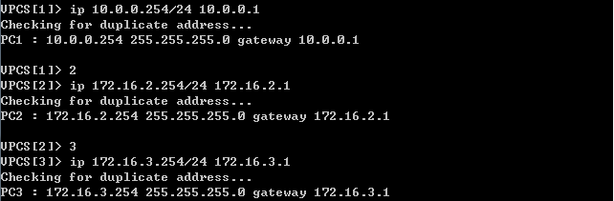

3. 检查连通性
主机与网关：
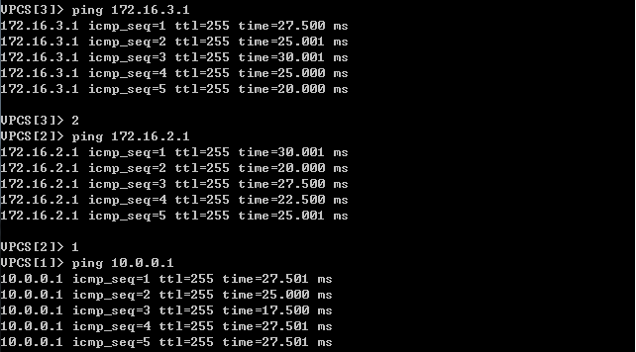
相邻路由器之间：
R2#ping 172.16.0.1
Type escape sequence to abort.
Sending 5, 100-byte ICMP Echos to 172.16.0.1, timeout is 2 seconds:
!!!!!
Success rate is 100 percent (5/5), round-trip min/avg/max = 12/25/56 ms

R2#ping 172.16.0.6
Type escape sequence to abort.
Sending 5, 100-byte ICMP Echos to 172.16.0.6, timeout is 2 seconds:
!!!!!
Success rate is 100 percent (5/5), round-trip min/avg/max = 16/20/28 ms

4. 配置EBGP对等体
R1(config)#router bgp 65001
R1(config-router)#neighbor 172.16.0.2 remote-as 65002
R1(config-router)#network 10.0.0.0 mask 255.255.255.0
R1(config-router)#exit
R1(config)#
*Mar 1 00:25:45.531: %BGP-5-ADJCHANGE: neighbor 172.16.0.2 Up

R2(config)#router bgp 65002
R2(config-router)#neighbor 172.16.0.1 remote-as 65001
R2(config-router)#
*Mar 1 00:25:44.195: %BGP-5-ADJCHANGE: neighbor 172.16.0.1 Up
R2(config-router)#exit

5. 配置IBGP对等体
配置指向环回接口的静态路由：
R2(config)#ip route 3.3.3.0 255.255.255.0 s1/1

R3(config)#ip route 2.2.2.0 255.255.255.0 s1/1

使用环回接口配置IBGP对等体：
R2(config)#router bgp 65002
R2(config-router)#neighbor 3.3.3.3 remote-as 65002
R2(config-router)#neighbor 3.3.3.3 update-source lo2
R2(config-router)#neighbor 3.3.3.3 next-hop-self
R2(config-router)#network 172.16.2.0 mask 255.255.255.0
R2(config-router)#exit
R2(config)#
*Mar 1 00:36:16.895: %BGP-5-ADJCHANGE: neighbor 3.3.3.3 Up

R3(config)#router bgp 65002
R3(config-router)#neighbor 2.2.2.2 remote-as 65002
R3(config-router)#
*Mar 1 00:36:15.539: %BGP-5-ADJCHANGE: neighbor 2.2.2.2 Up
R3(config-router)#neighbor 2.2.2.2 update-source lo3
R3(config-router)#neighbor 2.2.2.2 next-hop-self
R3(config-router)#network 172.16.3.0 mask 255.255.255.0
R3(config-router)#exit
R3(config)#

6. 检查路由表以及BGP对等体关系
R1#show ip route | include B
172.16.0.0/16 is variably subnetted, 3 subnets, 2 masks
B 172.16.2.0/24 [20/0] via 172.16.0.2, 00:04:27
B 172.16.3.0/24 [20/0] via 172.16.0.2, 00:02:36
R1#show ip bgp
Network Next Hop Metric LocPrf Weight Path
*> 10.0.0.0/24 0.0.0.0 0 32768 i
*> 172.16.2.0/24 172.16.0.2 0 0 65002 i
*> 172.16.3.0/24 172.16.0.2 0 65002 i
R1#show ip bgp summary
BGP router identifier 172.16.0.1, local AS number 65001
Neighbor V AS MsgRcvd MsgSent TblVer InQ OutQ Up/Down State/PfxRcd
172.16.0.2 4 65002 19 18 4 0 0 00:14:59 2

R2#show ip route | include B
B 172.16.3.0/24 [200/0] via 3.3.3.3, 00:06:14
10.0.0.0/24 is subnetted, 1 subnets
B 10.0.0.0 [20/0] via 172.16.0.1, 00:17:03
R2#show ip bgp
Network Next Hop Metric LocPrf Weight Path
*> 10.0.0.0/24 172.16.0.1 0 0 65001 i
*> 172.16.2.0/24 0.0.0.0 0 32768 i
*>i172.16.3.0/24 3.3.3.3 0 100 0 i
R2#show ip bgp summary
BGP router identifier 2.2.2.2, local AS number 65002
Neighbor V AS MsgRcvd MsgSent TblVer InQ OutQ Up/Down State/PfxRcd
3.3.3.3 4 65002 12 13 4 0 0 00:07:09 1
172.16.0.1 4 65001 21 22 4 0 0 00:17:42 1

R3#show ip route | include B
B 172.16.2.0/24 [200/0] via 2.2.2.2, 00:09:29
10.0.0.0/24 is subnetted, 1 subnets
B 10.0.0.0 [200/0] via 2.2.2.2, 00:09:29
R3#show ip bgp
Network Next Hop Metric LocPrf Weight Path
*>i10.0.0.0/24 2.2.2.2 0 100 0 65001 i
*>i172.16.2.0/24 2.2.2.2 0 100 0 i
*> 172.16.3.0/24 0.0.0.0 0 32768 i
R3#show ip bgp summary
BGP router identifier 3.3.3.3, local AS number 65002
Neighbor V AS MsgRcvd MsgSent TblVer InQ OutQ Up/Down State/PfxRcd
2.2.2.2 4 65002 15 14 4 0 0 00:09:39 2

7. 检查主机间的连通性
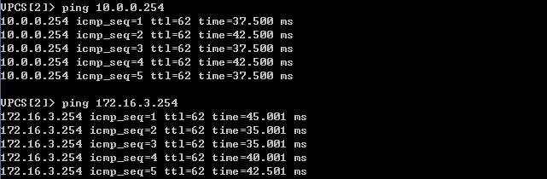
四、进阶技能的任务与要求
根据相关的技术与背景知识，并以前面的基本技能训练为基础，请尝试自主完成以下任务：
某企业网络及IP规划如图6.9.2所示，请按以下要求完成路由的规划与配置：
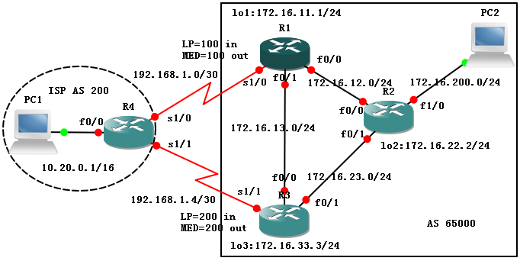
图2 “BGP的配置与管理”之进阶技能
1）在整个网络中，采用BGP实现与ISP的连通。
2）在企业网络的两台路由器上对企业网络进行路由汇总。
3）优先选择总部的边缘路由器R1作为互联网流量进入企业的入口，并优先选择分公司的边缘路由器R3作为访问互联网流量的出口。

五、进阶技能的规划设计与步骤
1. IP地址规划，见图；
2. IGP协议规划：在企业网络内部运行单区域OSPF路由协议。其中R1参与的接口有fa0/0, fa0/1, lo1；R2参与的接口有fa0/0, fa0/1, fa1/0, lo2；R3参与的接口有fa0/0, fa0/1, lo3；
3. 路由汇总规划：在R1和R3上生成指向null0接口的静态路由172.16.0.0/16；
4. BGP对等体关系规划：R4与R1、R3形成EBGP对等体，企业内三台路由器形成全互联的IBGP对等体，均使用自身的环回接口；
5. 路由策略规划：如图所示，通过在R1、R3上对与EBGP对等体R4相关的本地优先级（Local Preference）和MED值进行设备来控制数据的出入。具体地
R1→R4: MED=100, R1←R4: LP=100
R3→R4: MED=200, R3←R4: LP=200。
六、进阶技能实验结果与分析
1. 基本连通性配置（路由器名称与接口IP地址、动态路由协议、静态路由协议、主机IP地址相关配置）
主机IP地址：
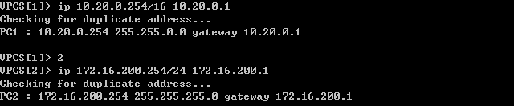
R1#sh ip int b
Interface IP-Address OK? Method Status Protocol
FastEthernet0/0 172.16.12.1 YES manual up up
FastEthernet0/1 172.16.13.1 YES manual up up
Serial1/0 192.168.1.2 YES manual up up
Serial1/1 unassigned YES unset administratively down down
Serial1/2 unassigned YES unset administratively down down
Serial1/3 unassigned YES unset administratively down down
Loopback1 172.16.11.1 YES manual up up
R2#sh ip int b
Interface IP-Address OK? Method Status Protocol
FastEthernet0/0 172.16.12.2 YES manual up up
FastEthernet0/1 172.16.23.2 YES manual up up
FastEthernet1/0 172.16.200.1 YES manual up up
Loopback2 172.16.22.2 YES manual up up
R3#sh ip int b
Interface IP-Address OK? Method Status Protocol
FastEthernet0/0 172.16.13.3 YES manual up up
FastEthernet0/1 172.16.23.3 YES manual up up
Serial1/0 unassigned YES unset administratively down down
Serial1/1 192.168.1.6 YES manual up up
Serial1/2 unassigned YES unset administratively down down
Serial1/3 unassigned YES unset administratively down down
Loopback3 172.16.33.3 YES manual up up
R4#sh ip int b
Interface IP-Address OK? Method Status Protocol
FastEthernet0/0 10.20.0.1 YES manual up up
FastEthernet0/1 unassigned YES unset administratively down down
Serial1/0 192.168.1.1 YES manual up up
Serial1/1 192.168.1.5 YES manual up up
Serial1/2 unassigned YES unset administratively down down
Serial1/3 unassigned YES unset administratively down down

R1# sh ip route | exclude C
172.16.0.0/16 is variably subnetted, 8 subnets, 2 masks
O 172.16.200.0/24 [110/21] via 172.16.13.3, 00:06:50, FastEthernet0/1
O 172.16.33.0/24 [110/11] via 172.16.13.3, 00:06:24, FastEthernet0/1
O 172.16.22.0/24 [110/21] via 172.16.13.3, 00:06:40, FastEthernet0/1
O 172.16.23.0/24 [110/20] via 172.16.13.3, 00:06:50, FastEthernet0/1
S 172.16.0.0/16 is directly connected, Null0
R2#sh ip route | exclude C
172.16.0.0/24 is subnetted, 7 subnets
O 172.16.33.0 [110/11] via 172.16.23.3, 00:05:34, FastEthernet0/1
O 172.16.13.0 [110/20] via 172.16.23.3, 00:05:49, FastEthernet0/1
O 172.16.11.0 [110/21] via 172.16.23.3, 00:05:49, FastEthernet0/1
R3#sh ip route | exclude C
172.16.0.0/16 is variably subnetted, 8 subnets, 2 masks
O 172.16.200.0/24 [110/11] via 172.16.23.2, 00:04:27, FastEthernet0/1
O 172.16.22.0/24 [110/11] via 172.16.23.2, 00:04:27, FastEthernet0/1
O 172.16.12.0/24 [110/20] via 172.16.23.2, 00:04:27, FastEthernet0/1
[110/20] via 172.16.13.1, 00:04:27, FastEthernet0/0
O 172.16.11.0/24 [110/11] via 172.16.13.1, 00:04:27, FastEthernet0/0
S 172.16.0.0/16 is directly connected, Null0
192.168.1.0/30 is subnetted, 1 subnets

2. BGP对等体配置
配置：
R1#sh run | begin router bgp
router bgp 65000
no synchronization
network 172.16.0.0
neighbor 172.16.22.2 remote-as 65000
neighbor 172.16.22.2 update-source Loopback1
neighbor 172.16.22.2 next-hop-self
neighbor 172.16.33.3 remote-as 65000
neighbor 172.16.33.3 update-source Loopback1
neighbor 172.16.33.3 next-hop-self
neighbor 192.168.1.1 remote-as 200
no auto-summary
R2#sh run | begin router bgp
router bgp 65000
no synchronization
neighbor 172.16.11.1 remote-as 65000
neighbor 172.16.11.1 update-source Loopback2
neighbor 172.16.11.1 next-hop-self
neighbor 172.16.33.3 remote-as 65000
neighbor 172.16.33.3 update-source Loopback2
neighbor 172.16.33.3 next-hop-self
no auto-summary
R3#sh run | begin router bgp
router bgp 65000
no synchronization
network 172.16.0.0
neighbor 172.16.11.1 remote-as 65000
neighbor 172.16.11.1 update-source Loopback3
neighbor 172.16.11.1 next-hop-self
neighbor 172.16.22.2 remote-as 65000
neighbor 172.16.22.2 update-source Loopback3
neighbor 172.16.22.2 next-hop-self
neighbor 192.168.1.5 remote-as 200
no auto-summary
R4#sh run | begin router bgp
router bgp 200
no synchronization
network 10.20.0.0 mask 255.255.0.0
neighbor 192.168.1.2 remote-as 65000
neighbor 192.168.1.6 remote-as 65000
no auto-summary
结果：
R1#sh ip route | include B
Codes: C - connected, S - static, R - RIP, M - mobile, B - BGP
B 10.20.0.0 [20/0] via 192.168.1.1, 00:01:59
R2#sh ip route | include B
Codes: C - connected, S - static, R - RIP, M - mobile, B - BGP
B 172.16.0.0/16 [200/0] via 172.16.33.3, 00:01:21
B 10.20.0.0 [200/0] via 172.16.33.3, 00:01:49
R3#sh ip route | include B
Codes: C - connected, S - static, R - RIP, M - mobile, B - BGP
B 10.20.0.0 [20/0] via 192.168.1.5, 00:02:51
R4#sh ip route | include B
Codes: C - connected, S - static, R - RIP, M - mobile, B - BGP
B 172.16.0.0/16 [20/0] via 192.168.1.6, 00:02:04
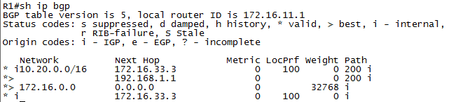
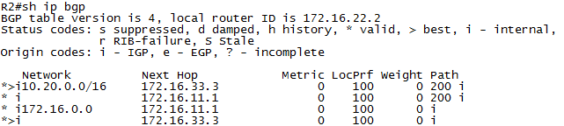
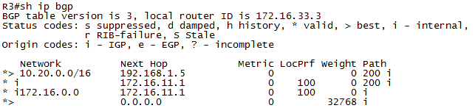
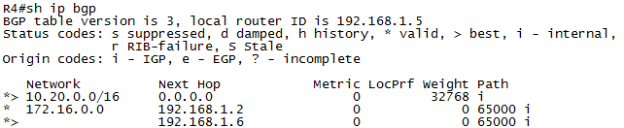*>

检查现有路由情况：
双向Ping：
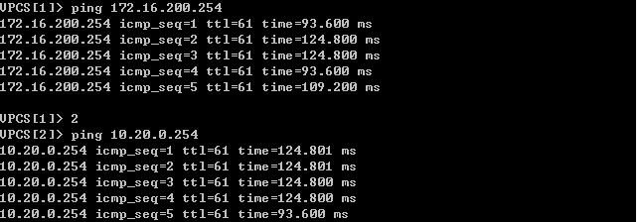
双向Trace：
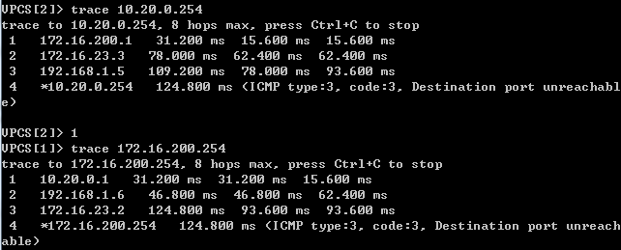
PC2→R2→R1→R4→PC1
PC1→R4→R3→R2→PC2

3. 路由策略部署（仅改变R1与R3的配置，然后在R4上重置BGP进程）

R1：
router bgp 65000
neighbor 192.168.1.1 route-map LP_100 in
neighbor 192.168.1.1 route-map MED_100 out
!
access-list 1 permit 10.20.0.0 0.0.255.255
access-list 2 permit 172.16.0.0 0.0.255.255
!!
route-map MED_100 permit 10
match ip address 2
set metric 100
!
route-map MED_100 deny 20
!
route-map LP_100 permit 10
match ip address 1
set local-preference 100
!
route-map LP_100 deny 20

R3：
router bgp 65000
neighbor 192.168.1.5 route-map LP_200 in
neighbor 192.168.1.5 route-map MED_200 out
no auto-summary
!
access-list 1 permit 10.20.0.0 0.0.255.255
access-list 2 permit 172.16.0.0 0.0.255.255
!
!
route-map MED_200 permit 10
match ip address 2
set metric 200
!
route-map MED_200 deny 20
!
route-map LP_200 permit 10
match ip address 1
set local-preference 200
!
route-map LP_200 deny 20

R4#clear ip bgp *
R4#
*Mar 1 01:08:44.047: %BGP-5-ADJCHANGE: neighbor 192.168.1.2 Down User reset
*Mar 1 01:08:44.055: %BGP-5-ADJCHANGE: neighbor 192.168.1.6 Down User reset
*Mar 1 01:08:44.295: %BGP-5-ADJCHANGE: neighbor 192.168.1.2 Up
*Mar 1 01:08:44.703: %BGP-5-ADJCHANGE: neighbor 192.168.1.6 Up

结果：
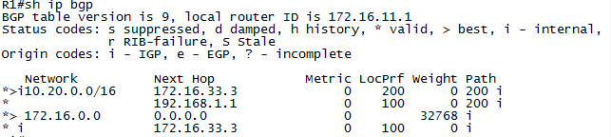
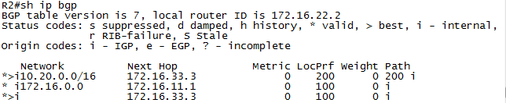
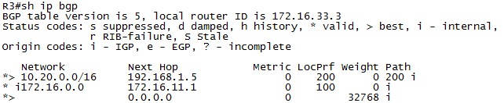
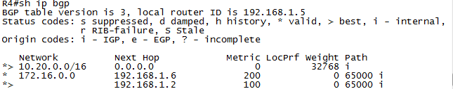
BGP路由发生了改变：
R1#sh ip route | include B
Codes: C - connected, S - static, R - RIP, M - mobile, B - BGP
B 10.20.0.0 [200/0] via 172.16.33.3, 00:10:23
R2#sh ip route | include B
Codes: C - connected, S - static, R - RIP, M - mobile, B - BGP
B 172.16.0.0/16 [200/0] via 172.16.33.3, 00:46:05
B 10.20.0.0 [200/0] via 172.16.33.3, 00:13:31
R3#sh ip route | include B
Codes: C - connected, S - static, R - RIP, M - mobile, B - BGP
B 10.20.0.0 [20/0] via 192.168.1.5, 00:13:56
R4# sh ip route | include B
Codes: C - connected, S - static, R - RIP, M - mobile, B - BGP
B 172.16.0.0/16 [20/100] via 192.168.1.2, 00:12:03
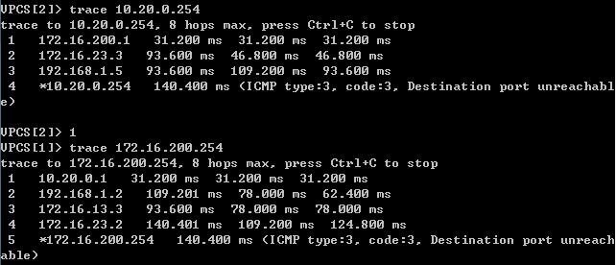
PC2→R2→R3→R4→PC1
PC1→R4→R1→R3→R2→PC2

七：思考题：
- 在声明EBGP对等体时，是否应该定义update-source选项？为什么？
- BGP路由器在使用network命令宣告网络时，是否能宣告一个并不是自己直连的网络？为什么？
3．是不是自治系统中所有的路由器都应该运行BGP？为什么？

八、教师评语：

实验成绩： 教师：（签名要全称） 年 月 日

注：1。此模板为专业实验报告的基本要求，若有特殊要求的实验，可在此模板基础上增加，但不可减少。
２．实验报告必须在学生提交报告后一星期内批改。
另附创新技能方案及结果分析
说明：
- 上下页边距改成2厘米，左边距为2.0厘米，右边距为1.5厘米。
- 表格位置为居中

创新活动：
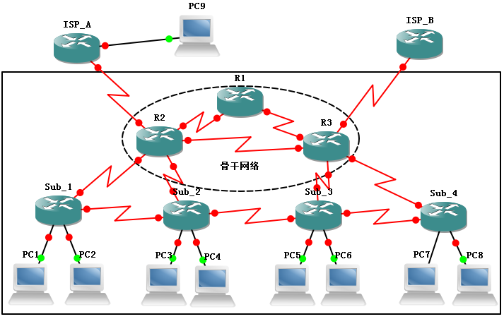
图3 “BGP的配置与管理”之创新活动
某企业的网络拓扑如图6.9.3所示，企业有较多的分部，以后分部数目还会继续不断的增加，且每个分部的子网规模均超过200以上。其中总部的骨干网络有多个到ISP的连接，这些连接个数还将不断增加。现有人向你建议了如下的路由规划：
- 在企业内部，采用多区域OSPF实现动态路由，其中总公司以及总公司与分公司的连接属于主干区域。
- 在企业与各ISP之间，通过BGP路由协议实现自治系统间互联。为达到可以完全操纵路径选择的目的，企业与ISP交换完整的路由信息。
- 在企业网络内部，所有路由器都运行BGP路由协议，并与任意其它路由器形成IBGP对等体关系。
请你完成以下工作：
- 根据该建议，给出路由的具体配置方案并付诸实施；
- 分析与判断该方案的可行性，分析方案对企业内部非骨干网络的路由器造成的影响
- 搜集并讨论可能的解决方案。

